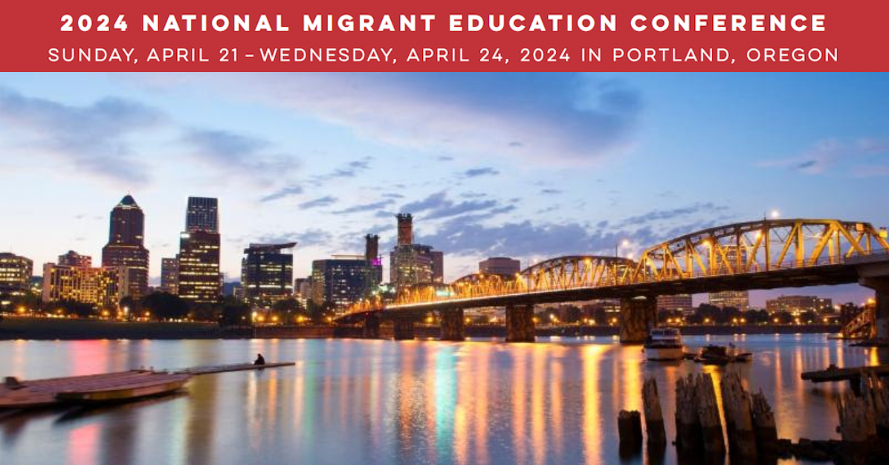

|  |  |
| --- | --- |
| |  | | --- | | **NATIONAL MIGRANT EDUCATION CONFERENCE OVERFLOW HOTEL** | |

|  |  |
| --- | --- |
| |  | | --- | | We are having a wonderful and overwhelming response to the 55th Annual National Migrant Education Conference in Portland, Oregon (April 21 - 24).  Currently the two Hilton properties are very close to filled or have filled. We do urge attendees to continue to check for availability at these hotels, as often people have to cancel their reservations and some rooms will go back into inventory for you to reserve.  However, in the meantime, we have arranged for additional rooms at the Paramount Hotel which is a block from the Broadway entrance to the Hilton Portland Downtown.  As you know, National Conference attendees must make their own lodging arrangements. | |

|  |  |
| --- | --- |
| |  | | --- | | **LODGING INFORMATION**  [**The Paramount Hotel**](https://r20.rs6.net/tn.jsp?f=0016IYyoqYkanHTq5RsmAJfOB2z3pAMShzZgIvF70rZRV26BQ8pbPeCCy7Wn8WFsPakpk3ml4dqEPvp0rJgf6TiMcrA661CnuQiev-niyFSiGkNtnc-S7XdzCsFt0zUUx8jsZArKighjOKBuqXpFAE0jvc4FS1LVGhb&c=w9WbcoIXnXTZGS9Hz9pHAefF79NrBeTTiN5C9EXxZ0aJwhM6F8Pfew==&ch=S632kOTFKzIEgsz90FBBXt6ilzi9m81H2YMmJEhsdxzjzMwC1kFPxA==)  808 SW Taylor Street  Portland, OR 97205 | |

|  |  |  |
| --- | --- | --- |
| |  | | --- | |  |  |  | | --- | | It has been a popular hotel with our attendees at past conferences with its European-style boutique ambiance and curated artwork. Amenities include complimentary WiFi and access to the fitness center.  The rate is $185 (for a single or double), plus all applicable taxes and fees.  Please use [**this link**](https://r20.rs6.net/tn.jsp?f=0016IYyoqYkanHTq5RsmAJfOB2z3pAMShzZgIvF70rZRV26BQ8pbPeCCy7Wn8WFsPakovlZMvNdPnDCNnN-8Y1-8MEYbgtmqz2U8Ev7e-yNfnjAgn3t4_h9FL7QFbhClTH97cFF3NB1UpTcnQAMLGrSUGLIM8Edihvcdy_wFEBP0-mAs4Cdp7AFJiDYwY_IsKB8_f6fItGXWYy-99Qc8DW8O9S4mE6-cKw5&c=w9WbcoIXnXTZGS9Hz9pHAefF79NrBeTTiN5C9EXxZ0aJwhM6F8Pfew==&ch=S632kOTFKzIEgsz90FBBXt6ilzi9m81H2YMmJEhsdxzjzMwC1kFPxA==) to make reservations online. To make reservations by phone, call (503) 223-9900, choose option 0 and speak with the front desk and reference the group code **NASDMEAC** to receive the discounted rate.  The cutoff date for reservations at the group rate is Saturday, March 30, 2024 or when the block is filled, whichever comes first.  \  **Individual Cancellation:** Reservations should be cancelled by 48 hours prior to arrival date and time. Cancellations made within 48 hours of arrival or no-show reservations will incur a one night's room and tax fee. | |